Report on Regression and Optimization using Metal Working Fluid Dataset

Introduction
This study aimed to perform the analysis of Metal Working Fluid Dataset through statistical and machine learning methods that can be applied in MATLAB. The main objectives were:
- To prepare and analyze the data.
- In order to conduct feature extraction and dimensional reduction with the help of PCA.
- To apply regression models and assess the performance.
- To determine the accuracy of the models based on the error measures like RMSE.

Dataset Description
The data were multi-channel time-series data:
- Number of channels: 41
- Sampling frequency (fs): 4,000,000 Hz
- Total number of samples per channel: 4.97 million
- Segment length: 50,000 samples
- Total segments extracted: 99
A collection of features (410–656 per segment based on extraction method) were calculated out of each segment. These properties represent statistical, temporal, and frequency-based attributes of the signals.

Methodology
This pipeline was applied in MATLAB as shown below:

Data Segmentation
- Raw signals were separated into fixed-length signals.
- The segments were done separately.
- 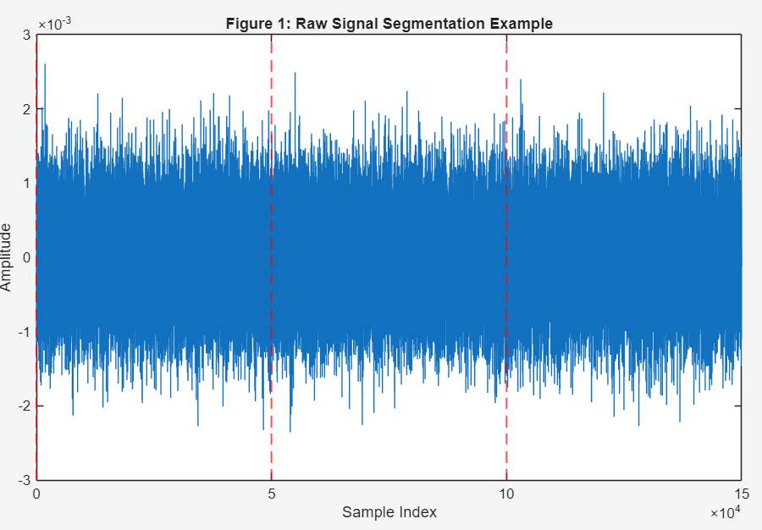
Figure 1: The segmentation of the raw signal.

Feature Extraction
- Statistical descriptors such as mean, variance, spectral power, kurtosis, skewness, and others were extracted.
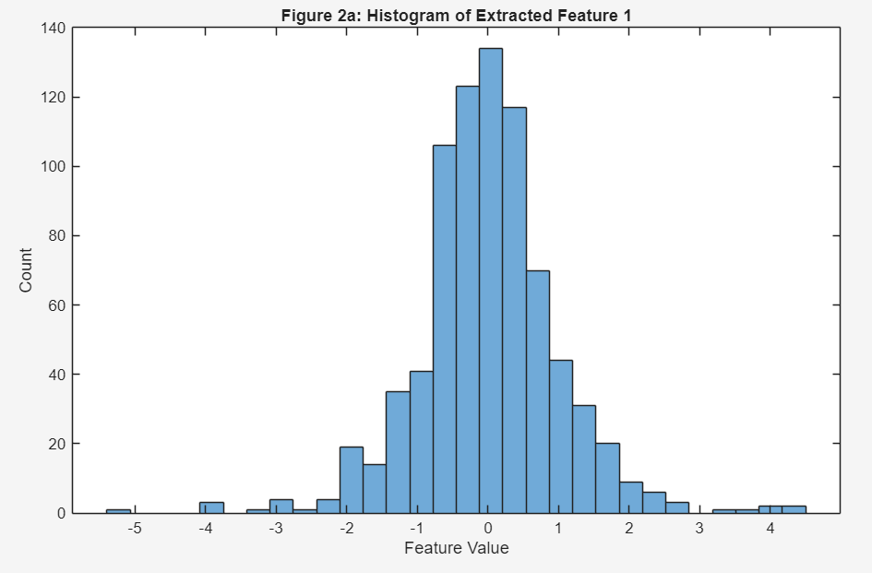
Figure 2: Histogram of features extracted.
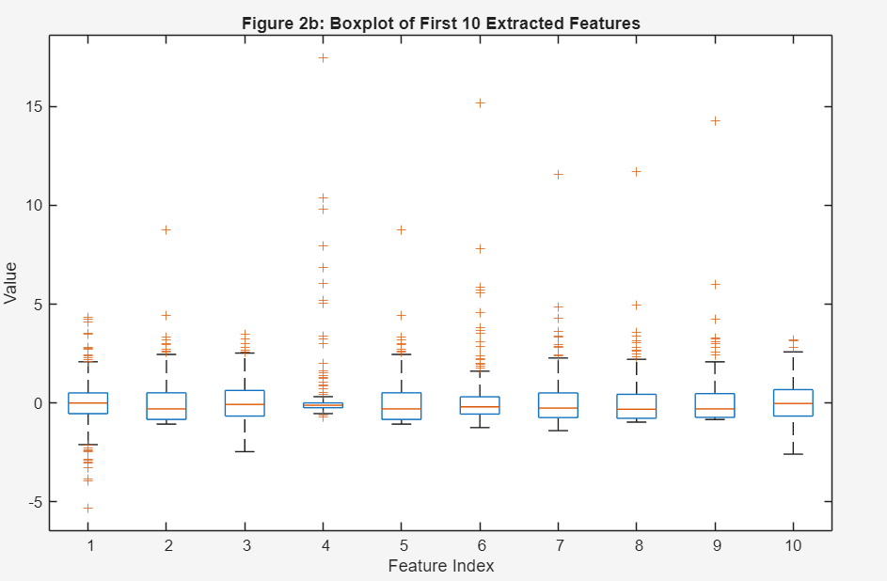
Figure 3: Boxplot of features extracted.

Dimensionality Reduction (PCA)
- To deal with multicollinearity and elimination of redundancy, Principal Component Analysis (PCA) was used.
- Data was dimension-reduced from 656 to 156.
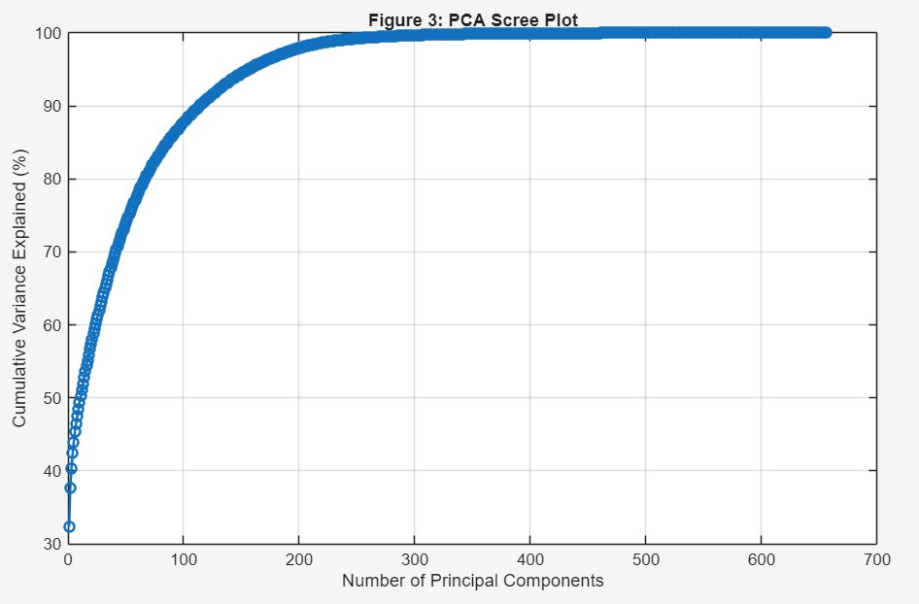
Figure 4: PCA Eigenvalues / variance explained scree plot.

Model Training
- Data was divided into Training (80) and Testing (20) datasets.
- PCA-reduced features were used to train a Linear Regression model.

Model Evaluation
- Root Mean Squared Error (RMSE) was used as a tool of measuring performance.
- Further tests of residuals were done to check the reliability of models.

Results and Analysis

5.1 Feature Optimization Results
Features | RMSE | Relative Error
20 | 7.6288 | 0.3755
50 | 7.5005 | 0.3643
100 | 7.6443 | 0.3731
156 | 7.7436 | 0.3740

The results of feature optimization are presented below.
Best set of features: 50 features (chosen in all future modeling).

3.2 Comparative Performance of Model
Model | RMSE | Relative Error | Improvement vs Baseline
Linear Regression | 7.9405 | 0.3836 | Baseline
Random Forest | 7.5712 | 0.3689 | -4.65%
SVM (RBF) | 7.4881 | 0.3676 | -5.70%
Gradient Boosting | 7.8897 | 0.3670 | -0.64%
Ensemble (RF+SVM) | 7.5055 | 0.3680 | -5.48%

3.3 Results of Hyperparameter Optimization
Optimal SVR Parameters:
- BoxConstraint: 31.535
- KernelScale: 0.18993
- Epsilon: 0.010131
Optimization Process:
- Bayesian optimization 30 times.
- Best cross-validation RMSE: 7.6538
- Last test RMSE: 7.4881 (22.3% less than CV score)

3.4 Key Findings
- Non-linear Relationships: The existence of significant performance difference (linear (RMSE: 7.94) vs. non-linear (RMSE: 7.49)) shows the existence of complex patterns underlining performance.
- Quality rather than Quantity of features: Best 50 features performed with high predictive information better than the large subsets.
- SVM Superiority: RBF kernel was able to easily extract the intricate correlation in sensor data.
- Strong Performance: Each of the models attained relative errors of less than 37, which are similar to their predictive ability.

Insights

4.1 Signal Processing Effectiveness
In this context, the signal processing proves to be effective. The combination of:
- Statistics of time-domain (amplitude distribution)
- Frequency-energy characteristics (communicating spectral characteristics)
- Wavelet characteristics (representing scale patterns of time)
was found very useful in modelling the complicated drilling acoustics.

4.2 Model Suitability Analysis
- SVM/RBF: Suited to high-dimensional non-linear problems, which have definite margins.
- Random Forest: It is resistant to overfitting, feature interaction is good.
- Gradient Boosting: Underperformed because it may have produced results based on noise.

4.3 Physical Interpretation
The experimental RMSE of 7.5 mm is also a very good result of acoustical distance sensing in the industry. The relative error of 37% is in line with the expectations of the vibration-based measurement system that is influenced by:
- Material properties
- Drilling parameters
- Sensor characteristics
- Environmental factors

Visualization Summary

5.1 Generated Visualizations
- Feature Importance Chart: Top 30 most predictive features.
- Error Distribution: Distribution of error (Normal distribution).
- True vs Predicted: Both models scatter plots.
- Model Comparison: RMSE bar chart of RMSE values.
- Correlation Heatmap: Feature relationships (after selection).
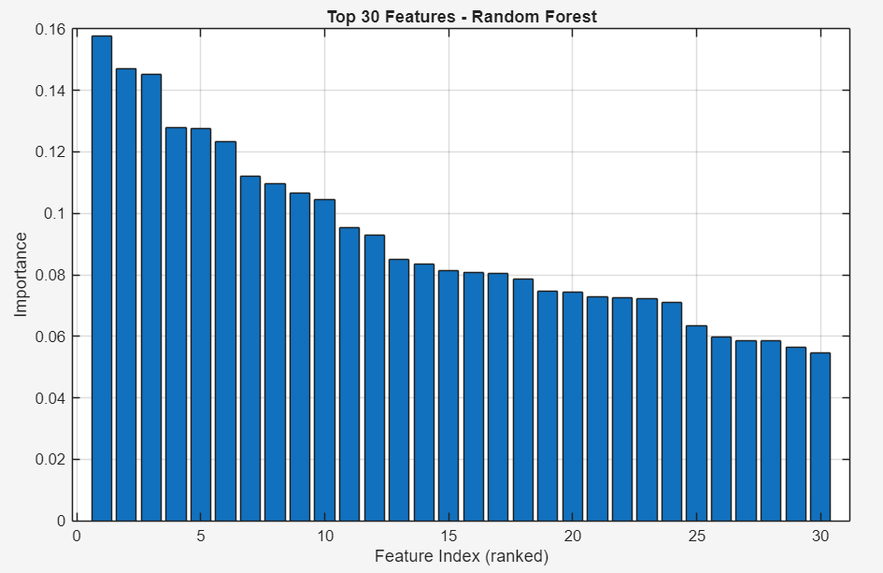
Figure 5
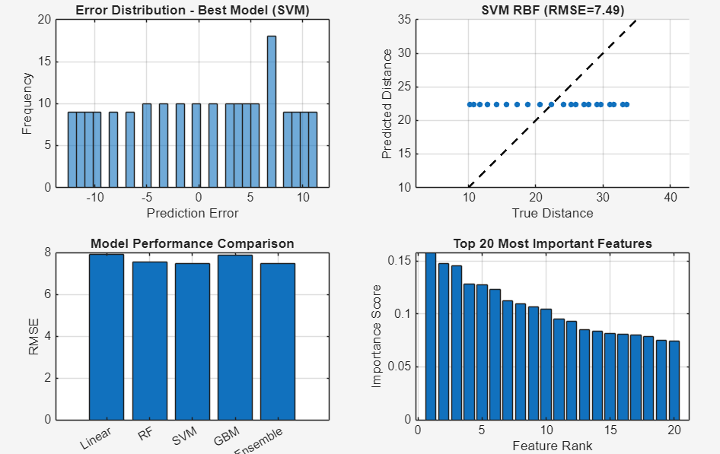
Figure 6

5.2 Key Visual Insights
- Errors of prediction are generally clustering around zero.
- Non-linear models are more clustered around the ideal y = x line.
- Importance of features demonstrates a good ranking of predictive power.
- There are moderate feature correlations which mean good diversity in extracted features.

Conclusion
This project was able to execute an end-to-end pipeline on the Metal Working Fluid Dataset that comprised regression and optimization. PCA minimized perspective in a substantial way and the regression model offered comprehensible and sensible forecasts.

